- Nutrients
- There are five components of food viz. Carbohydrates, fats, proteins, vitamins and minerals. These components of food are called nutrients.
- All living organisms (Plants, Animals and Human beings) require food.
- The nutrients enable living organisms to grow, to build their bodies and provide energy to carry out life processes (Nutrition, respiration, digestion, excretion, reproduction, metabolism and transportation).
- Plants are the only organisms that can prepare their own food but animals and humans cannot. That means humans and animals are dependent on plants.
- Plants make their own food by using water, minerals and carbon dioxide which are present in their surroundings.

- Mode of Nutrition in Plants:
- Nutrition: Nutrition is the process of taking food by organism and it’s usage by the body.

- There are two types of mode of nutrition.
(a) Autotrophic mode nutrition.
(b) Heterotrophic mode of nutrition.

(a) Autotrophic mode of nutrition: (auto-self, trophos-nourishment)
- The mode of nutrition in which organisms make food for them is known as Autotrophic nutrition.
e.g.- Plants.

(b) Heterotrophic mode of nutrition: (heteros-other)
- The mode of nutrition in which organisms (animals and humans) depends on other organisms (plants) for their food. They are unable to make their own food, are called Heterotrophic nutrition.
e.g. – Human beings, animals.

- Photosynthesis: (Food making process in plants)

- The leaves are the food factories of plants.
- Water and minerals are present in the soil are absorbed by the roots and transported to the leaves by the vessels.
- The vessels run like pipe throughout the roots, the steam, the branches and the leaves and they form a continuous path for the nutrients to reach the leaf.
- From air, carbon dioxide is taken in through the pores present on the surface of leaves.
- These pores are surrounded by ‘guard cells’ called stomata.
- The leaves have a green pigment called chlorophyll which helps leaves to absorb the energy of the sunlight.
- The preparation of food from carbon dioxide and water occurs in the presence of sunlight is called Photosynthesis.
- That means, for the process of photosynthesis chlorophyll, sunlight, carbon dioxide and water are essential.
- In the absence of photosynthesis there would not be any food. The survival of almost all living organisms directly or indirectly depends upon food made by the plants.
- Oxygen, the most crucial element which is essential for the survival of all living organisms is formed and released during photosynthesis.
- During photosynthesis, chlorophyll containing cells of leaves, in the presence of sunlight, use carbon dioxide and water to synthesise carbohydrates.
- Starch is present in leaves which is a carbohydrate indicates the occurrence of photosynthesis.
- The process can be represented in an equation as follows:
- Carbon dioxide + Water Sunlight Carbohydrates(glucose) + Oxygen
- (CO2) (H2O) Chlorophyll (C6H12O6) (O2)
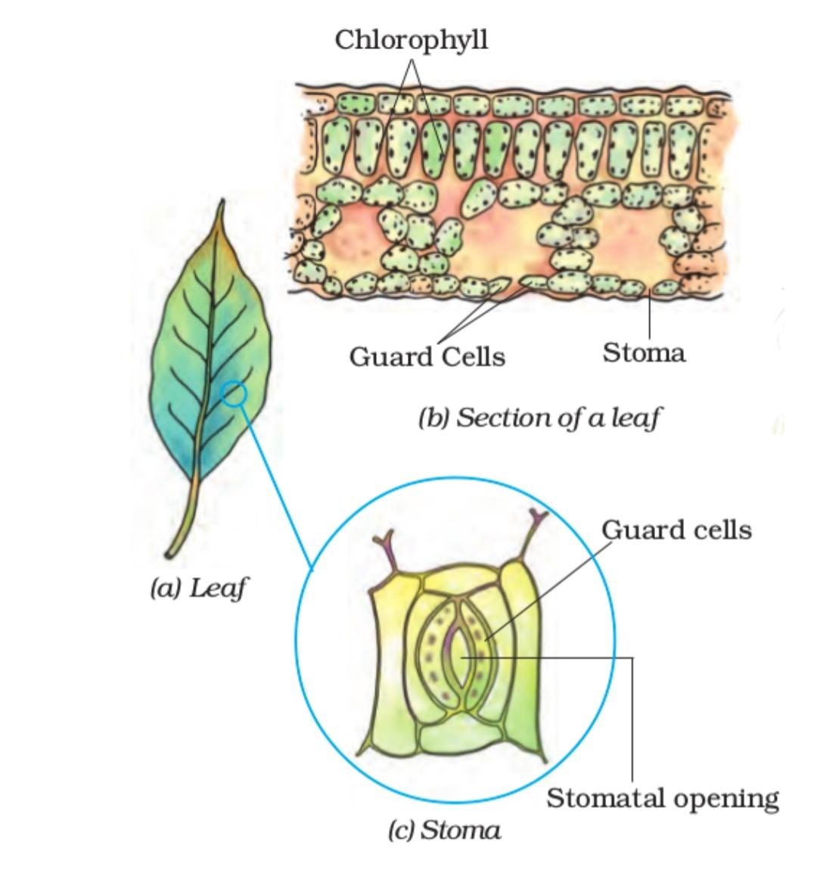
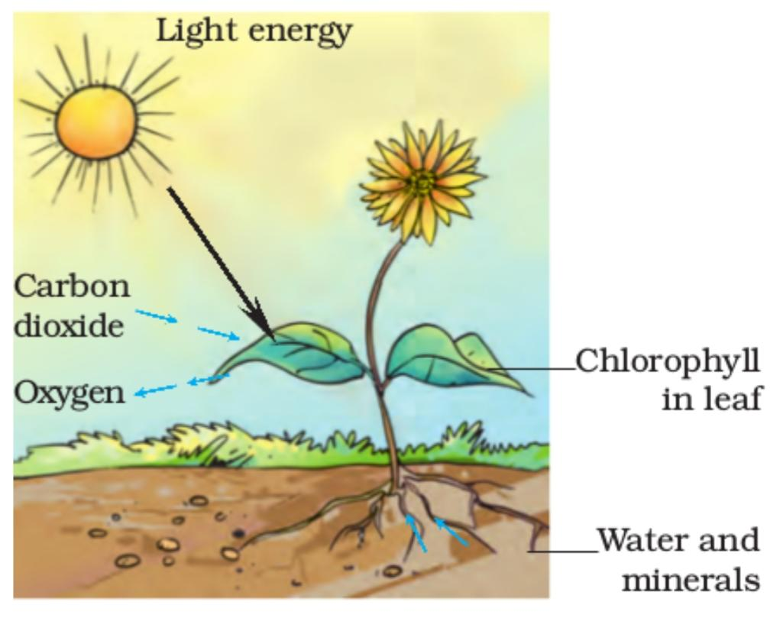
Photosynthesis

- The leaves other than green also have chlorophyll.
- The large amount of red, brown and other pigments mask the green colour.
- Photosynthesis takes place in these leaves also
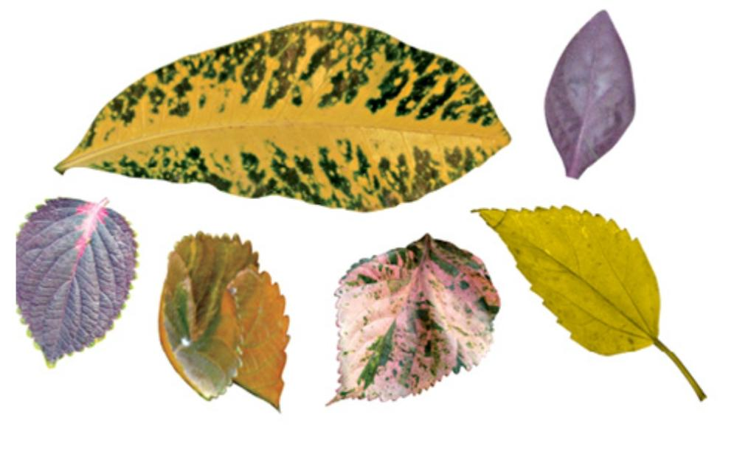
Leaves of various colours

- Synthesis of plant food other than carbohydrates

- The carbohydrates are made of carbon, hydrogen and oxygen.
- These are used to synthesise other components of food such as proteins and fats.
- But proteins contain nitrogen which is present in air(gaseous state).
- However, plants unable to absorb in this form.
- Soil has bacteria that convert gaseous nitrogen into a usable form.
- Then absorbed by the plants along with water.
- Also, farmers adding fertilisers rich in nitrogen to the soil.
- In this way the plants fulfil their requirements of nitrogen. Then synthesise proteins and vitamins.

- Other Modes of Nutrition in plants
- Some plants have no chlorophyll. Hence, cannot synthesise food.
- Such plants depend on the other plants which produced food.
- Therefore, such plants are heterotropic mode of nutrition.
- Example, Cuscuta (Amarbel-yellow wiry branched structure twining around the stem and branches of a tree) having no chlorophyll is called parasite.
- The plant on which it climbs is called the host from which it takes food.
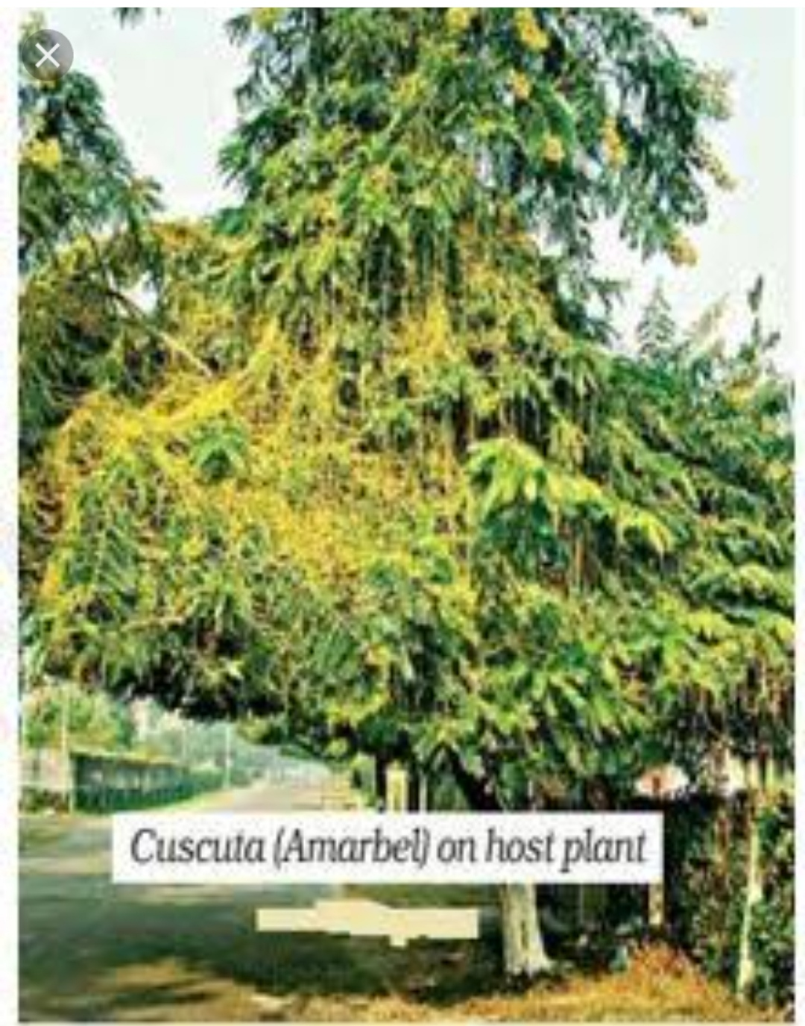

- Few plants may not be green or of some other colour. Trap insects and digest them.
- The jug-like structure is the modified part of leaf.
- The apex of the leaf forms a lid which can open and close the mouth of the pitcher.
- Inside the pitcher there are hair which are directed downwards.
- When an insect lands in the pitcher, the lid closes and the trapped insect gets entangled into the hair.
- The lid closes and the insect is trapped.
- The insect is digested by the digestive juices secreted in the pitcher and its nutrients are absorbed.
- Such insect-eating plants are called insectivorous plants.
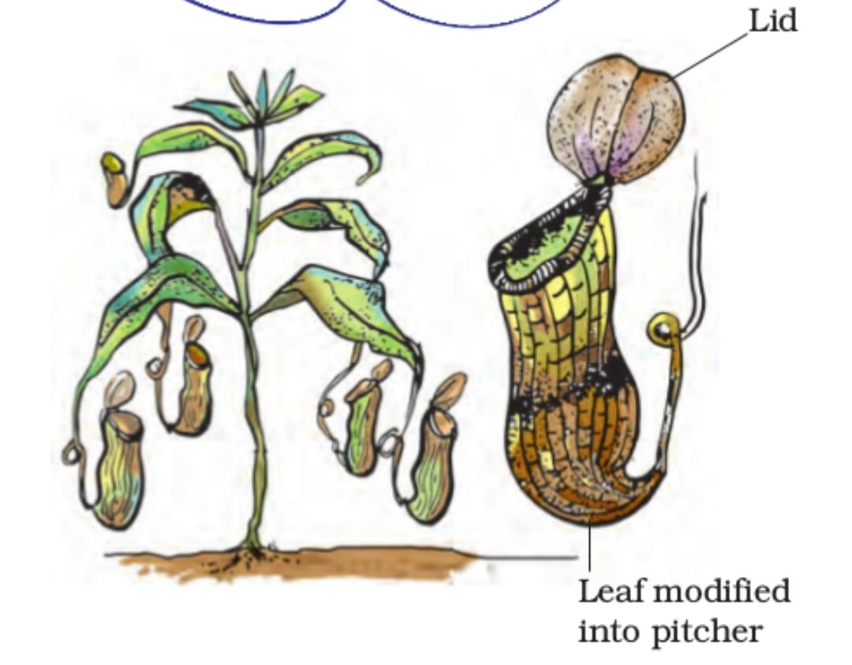

- Saprotrophs:

- This mode of nutrition in which organisms take in nutrients from dead and decaying matter is called saprotrophic nutrition.
- Such organisms are called saprotrophs.
- Example, Fungi grow on pickles, leather, clothes and other articles in hot and humid weather for long time.
- During the rainy season they spoil many things.
- The fungal spores are generally present in the air.
- When they land on wet and warm things they germinate and grow.
- Examples of fungi are Mushrooms and fluffy umbrella growing in moist soils or on rotting wood during the rainy season.
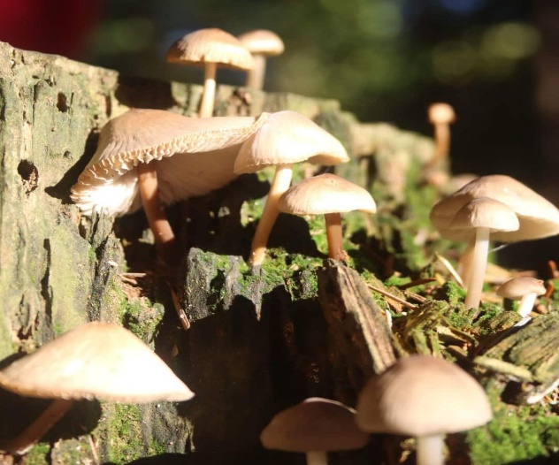
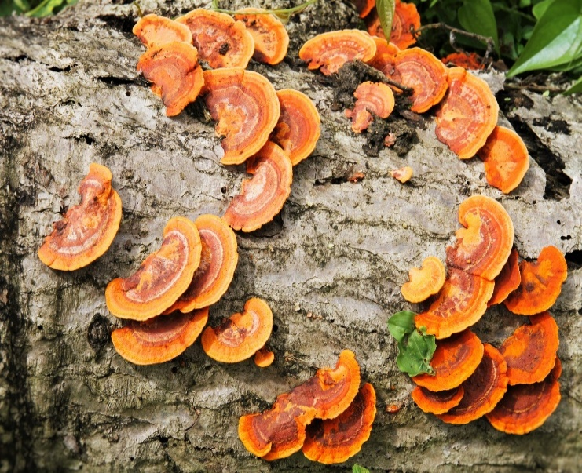
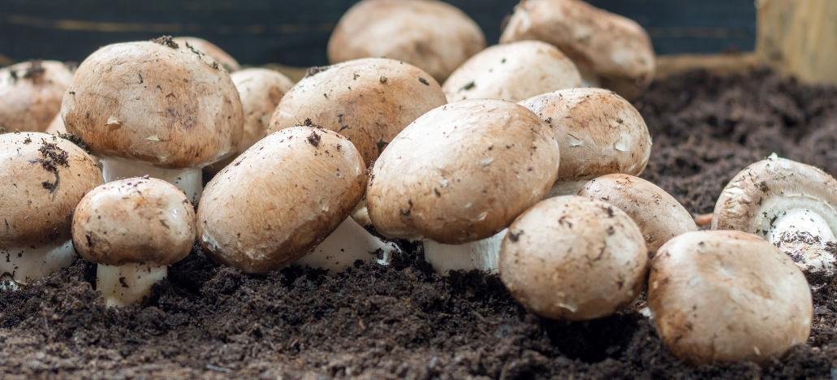

- Some organisms live together and share both shelter and nutrients. This relationship is called symbiosis.
- Example, some fungi live inside the roots of plants. The plants provide nutrients to the fungus and the fungus provides water and certain nutrients.
- In organisms called lichens, a chlorophyll-containing alga, and a fungus live together.
- The fungus provides shelter, water and minerals to the alga and the alga prepares and provides food to the fungus.

- How nutrients are replenished in the soil:

- Plants absorb minerals and nutrients from the soil. So, their amounts in the soil keep on declining.
- Fertilisers and manures contain nutrients such as nitrogen, potassium, phosphorous, etc.
- These nutrients need to be added from time to time to enrich the soil.
- Usually crop plants absorb a lot of nitrogen and the soil becomes deficient in nitrogen.
- They need nitrogen in a soluble form.
- The bacterium called Rhizobium can take atmospheric nitrogen and convert it into a usable form.
- But Rhizobium cannot make its own food.
- It lives in the roots of gram, peas, moong, beans and other legumes and provides them with nitrogen.
- In return, the plants provide food and shelter to the bacteria.
- Hence, have a symbiotic relationship.

